Turret Clock for Central London District School

In 1879, the firm of H & E Gaydon, Brentford, submitted the successful tender for the supply of a tower clock to the Central London District School at Hanwell, Middlesex, now the Borough of Ealing, London.
The Central London District School was established at Hanwell on 120 acres of land in 1856. It was set up under the English Poor Law system to accommodate pauper and orphaned children from the wider Central London District. In 1879 it was decided that an additional 3,500 gallon water tank should be installed on top of the then current tank in the central tower. This raising of the tower proved an opportunity to add a large central clock for the School.
Much of this story is based on the unpublished manuscript, ‘Central London Districts School Clock’, (‘The “Cuckoo” Clock’), by Chris G McKay and Chris’s research findings when he was involved in a restoration project of this clock across the late 1960s to the mid 1970s. Chris has generously provided access to his, as yet, unpublished writings and his file of letters, photographs and articles on this clock.

The formatting of the following articles has been changed a little to highlight points of relevance to this book. The original handwritten letters were copied by Chris McKay from the book of out-going letters of the School for the period 1878-1886 (Pages 415 – 418). The actions associated with these letters are based on the Minutes of various meetings of the School Managers relating to this period. In his manuscript, Chris has highlighted some perhaps unusual and intriguing behaviour associated with the defining and awarding of this contract. Presented here are the relevant letters relating only to the request for tender, the tender submitted by H & E Gaydon and the acceptance of this tender.

(a) Request for tender for Clock:
To: Each of (1) Gillet and Bland; (2) Smith & Son; (3) Thwaites & Reed; (4) Moore & Sons; (5) H & E Gaydon
From: Geo E East, Clerk, Central London District School, Hanwell
Dates: November 22nd 1879.
Sirs,
I am directed by the Managers to forward to you the enclosed specifications for a clock which they intend to place in the tower of their school at Hanwell. And they will be prepared to receive a tender from you for the same on or before Saturday next the 29th inst. Of course the managers do not bind themselves to accept the lowest or any tender.
Yours obedly

(b.1) Submission of tender for supply and installation of clock from H & E Gaydon
To: Central London District School, Hanwell
From: H & E Gaydon, 102 High Street, Brentford
Dates: November 29th 1879.
Specification for Turret Clock to be erected about 90 feet from the ground under the direction of Mr William Hudson Architect, 19 Bennets Hill, Doctors Common.
Provide and fix a superior eight day clock with three faces outside and one face inside for setting outside hands, to show hours and minutes, maintaining power during winding, Graham Dead beat escapement, heavy pendulum and adjusting screws – bell with wood rod 14 feet long or as long as the situation of the clock will allow, wheels of gun metal cut into high numbers 13 inches diameter for the going train and 15 inches diameter for the striking all finished in an engine – Pinions and pallets hardened and polished and faced up in the best manner.
The works enclosed in a strong iron frame with gun metal bosses for pivots Expanding and universal joints and rods to the outside dials. Three sets of hour and minutes motion work. A set of wrought iron hammer work with gun metal bearings on the most improved principle – 4 Cwt good toned bell for striking the hours and half hours. Copper dials 6 feet diameter and gilt copper hands and gilt with the best gold.
The whole of the gun metal work to be cleaned and lacquered, the iron work to be painted 3 coats and bronzed, all necessary pulleys and wire lines, the clock to be finished complete in every respect and set in motion and regulated for £178 10s.
If with 3 illuminated faces 6 feet diameter glazed with the best opal glass with wheels for regulating and turning up gas and down as required for the sum of £185.
One extra 6 feet diameter illuminated dial glazed with the best opal glass with motion work bevel wheels and rod work complete 10s.
The prices named include everything complete no extra charge whatever.

(b.2) Submission of tender for gas fitting to illuminate the clock from H & E Gaydon
To: Central London District School Hanwell
From: H & E Gaydon, 102 High Street, Brentford
Dates: November 29th 1879.
Estimate for gas fitting to illuminated clock faces.
To make three 5 feet circles with 6 taps elbows and gas burners in each with ½ inch pipe to each dial and fixing up the same with ¾ inch main pipe from the basement £6.
Making one extra circle if required for extra dial and all fittings necessary £1 10s.
The prices named include everything necessary and done in the best manner.
No Extras

(c) Acceptance of tender from Central London District School to H & E Gaydon.
To: H & E Gaydon, 102 High Street, Brentford
From: Geo East, Clerk, Central London District School, Hanwell
Dates: December 2nd 1879.
Gentlemen,
The managers accept your tender dated the 29th November for clock with four illuminated dials for the sum of £203 10 0 and they also approve your estimate £7 10 0 for providing and fitting the gas fittings to illuminate the faces – the several works being done under the superintendence of Mr. Hudson the manager’s architect with whom you will communicate as to the time of completion.
I am gentlemen your obedly

(d) Request for submission of account from Central London District School, Hanwell
To: H & E Gaydon, 102 High Street, Brentford
From: Geo E East, Clerk, Central London District School, Hanwell
Dates: 1st November 1880.

Dear Sir,
Have the goodness to send in your account for the clock to the manager’s architect, Mr Hudson of 19 Bennets Hill for examination.
Is any precaution necessary to guard against the pendulum giving way?
I am dear sir yours faithfully

For the first 30 years or so of its life the clock was under the service and maintenance of Gaydons of Brentford who would likely visit on a weekly basis to adjust the time and undertake any maintenance required. H & E Gaydon had long held the contract with the School for the setting and maintenance of its clocks. The following graph (Figure 6.2) is based on data extracted from the School Records.
These data show that Gaydons had been involved with the clocks of the School since it was built. Prior to the tower clock, one can speculate, with confidence, that there were a number of clocks around the buildings which regulated the activities of children and staff. Perhaps the expenses experienced in 1876 – 78, contributed towards the decision to install a central tower clock. One central clock must have been advantageous in the operation of the School especially with striking on the half hour in addition to the hour.
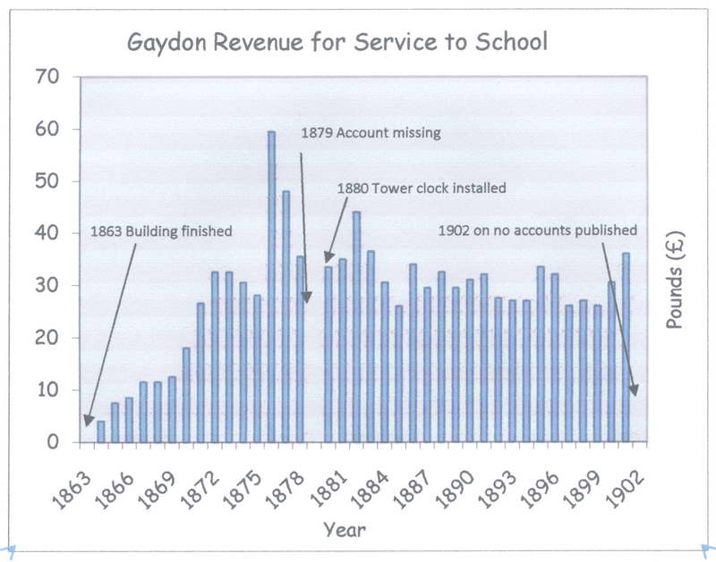

Figure 6.2

The School was closed in the late 1930s but the tower clock continued to operate until the late 1940s. McKay has speculated that a flying bomb during WWII broke the dials which allowed the weather and pigeons to invade the clock room and ultimately lead to the stopping of the clock. The story of its restoration, begun in 1969 but not completed until late 1974, as told by McKay, provides insights also into the School and its community. Perhaps the best known of all the children, who lived and were educated at the Central London District School at Hanwell, was Charlie Chaplin of silent movie fame. The buildings remaining in 2010 and the restored clock are shown in Figure 6.3.

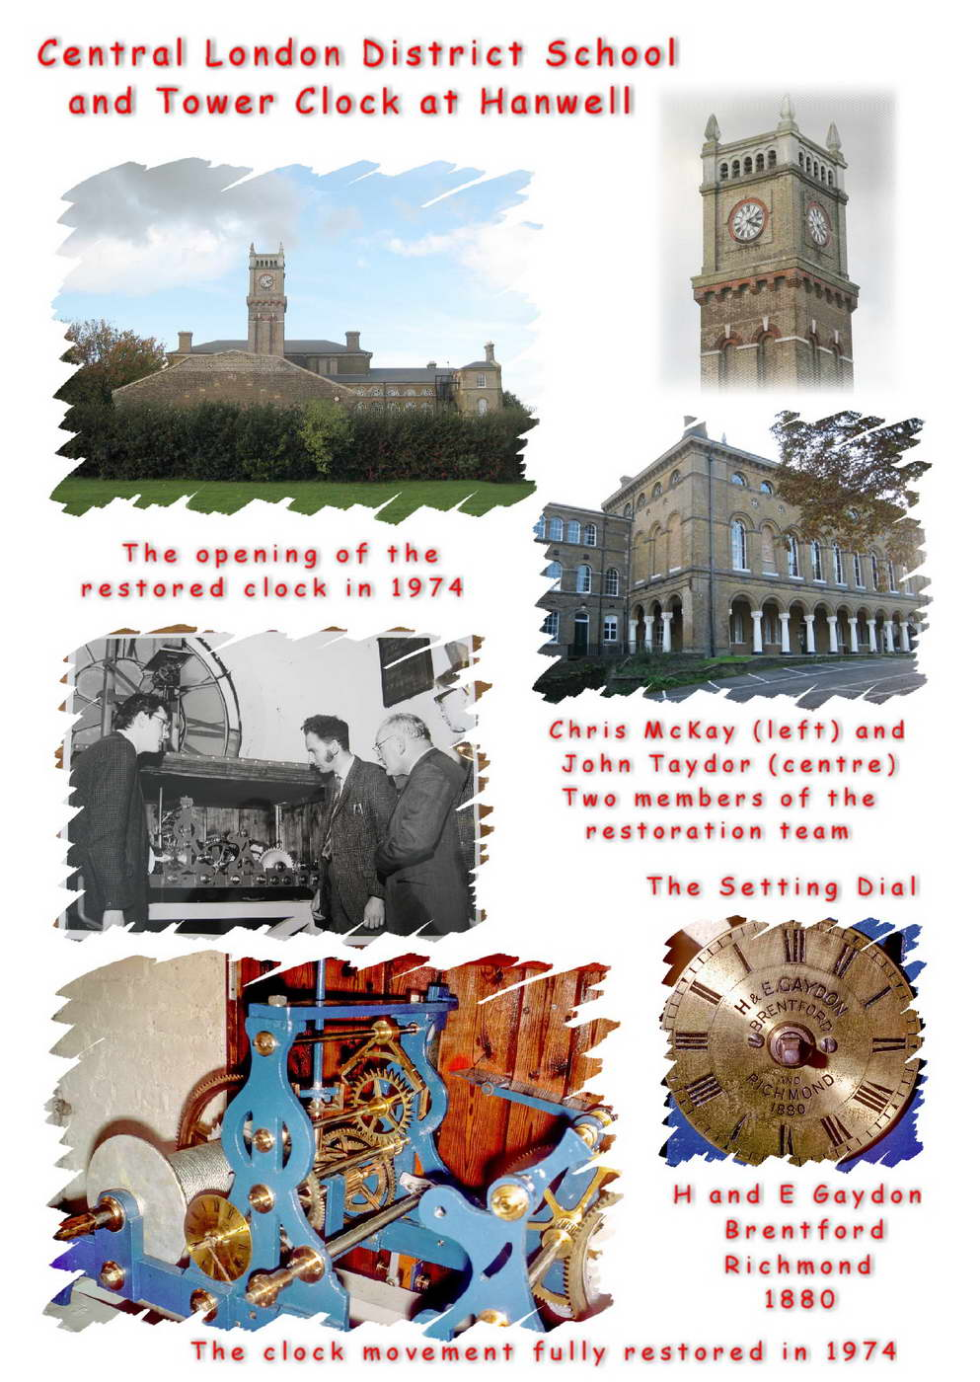

Figure 6.3

Chris McKay writes: ‘The clock is a Victorian 2 train flat bed movement of 1880. Escapement is of the dead beat type and the pendulum beats 2 seconds. ... It seems probable that the clock was made by JW Benson of London ....’

